IBM SkillsBuild Cyber Security BootCamp 2026
Conducted by BharatCares
PROJECT REPORT
Malware Classification using Machine Learning
Static Analysis of Windows PE Header Features
Submitted by: Ann Celin Jose
Branch / Stream: CSE
Institution: Sahrdaya College of Engineering and Technology (Autonomous), Kodakara
Date: 21-10-2026

Abstract
Malware remains one of the most persistent threats to individuals and organisations. Traditional signature-based antivirus tools struggle with new and modified malware because they can only detect threats they have already seen. This project applies machine learning to static malware analysis: it classifies Windows Portable Executable (PE) files as benign or malicious using only the values stored in the file's header, without executing it.
Using the ClaMP dataset of 5,210 labelled samples (2,488 benign and 2,722 malware; 5,207 remain after removing 3 duplicate rows), four classifiers (Logistic Regression, Decision Tree, Random Forest and Gradient Boosting) were trained and compared using stratified cross-validation and a held-out test set. Models were evaluated with accuracy, precision, recall, F1-score and ROC-AUC. Feature importance analysis was used to identify which header fields best distinguish malware from legitimate software.

1. Introduction
Every year millions of new malware samples are created, many of them small variations of existing families. Manually analysing each file is not practical, so automated detection is essential. Static analysis inspects a file without running it, which makes it fast and safe, because there is no risk of infection during analysis.
A Windows executable follows the Portable Executable (PE) format. Its header stores structured information such as the target machine type, number of sections, linker version, code and data sizes, and entry point. Malware authors often use packers, unusual compilers or modified headers, which leaves measurable differences between malicious and benign files. A machine learning model can learn these differences automatically.

2. Problem Statement
Given the PE header features of a Windows executable, build a model that predicts whether the file is benign (class 0) or malware (class 1) with high accuracy and a low rate of missed malware.

3. Objectives
- Load and explore a labelled PE header malware dataset.
- Clean and prepare the data for machine learning.
- Train and compare several classification algorithms.
- Evaluate models using metrics suited to security problems, especially recall for the malware class.
- Identify the most important header features.
- Save the best model so it can classify new samples.

4. Tools and Technologies
Tool | Purpose
Python 3 | Programming language
pandas, NumPy | Data loading, cleaning and numerical operations
scikit-learn | Model training, cross-validation and evaluation metrics
matplotlib, seaborn | Charts and visualisation
joblib | Saving and loading the trained model
Jupyter Notebook | Development environment

5. Dataset
The project uses the ClaMP (Classification of Malware with PE headers) dataset by Ajit Kumar, published on Mendeley Data (DOI: 10.17632/xvyv59vwvz.1) and also available on Kaggle. The integrated file (named ClaMP_Integrated-5184.csv) loaded as 5,210 samples of malware and benign executables.
Property | Details
File used | ClaMP_Integrated-5184.csv
Samples | 5,210 rows as loaded (5,207 after removing 3 duplicates)
Features | 69 feature columns plus the label; 60 numeric features used for training
Target column | class (0 = benign, 1 = malware)
Feature groups | DOS header, file header and optional header fields

Class balance: The dataset is almost balanced: 2,488 benign samples (47.8%) and 2,722 malware samples (52.2%), 5,210 in total. These counts are for the 5,210 rows as loaded. Three duplicate rows were then removed, leaving 5,207 samples (4,165 for training and 1,042 for testing). Because the classes are balanced, accuracy is a fair metric, and recall and precision are still reported for the malware class.

6. Methodology

6.1 Data Preprocessing
- Removed duplicate rows (3 were found).
- Kept numeric columns only; the text column packer_type was dropped.
- Filled missing values with the column median.
- Removed 8 constant columns that carry no information, leaving 60 features.
- Split the data 80% training and 20% testing, stratified by class, with random seed 42.

6.2 Models Used
Model | Description
Logistic Regression | Linear baseline model with standardised features.
Decision Tree | Learns a set of if-then rules; easy to interpret.
Random Forest | Ensemble of 300 decision trees voting together; robust and gives feature importance.
Gradient Boosting | Builds trees one after another, each correcting the errors of the previous ones.

6.3 Evaluation Metrics
- Accuracy: share of all files classified correctly.
- Precision: of the files flagged as malware, how many really are malware.
- Recall: of all real malware, how much was caught. This is critical because a missed malware sample is costly.
- F1-score: balance of precision and recall.
- ROC-AUC: how well the model separates the two classes across all thresholds.
- Confusion matrix: counts of true and false positives and negatives.

7. Implementation
The complete implementation is in the Jupyter Notebook submitted with this report. The workflow is: load the CSV, explore and visualise the data, preprocess, train the four models with 5-fold stratified cross-validation, evaluate on the held-out test set, plot the confusion matrix, ROC curves and feature importance, and save the best model with joblib so that it can predict on new samples.

8. Results and Discussion
Table 1 shows the performance of the four models on the held-out test set (20% of the data). Cross-validation accuracy was computed on the training set using 5-fold stratified cross-validation.
Model | CV Acc. | Test Acc. | Precision | Recall | F1 | ROC-AUC
Random Forest | 0.9902 | 0.9894 | 0.9890 | 0.9908 | 0.9899 | 0.9991
Gradient Boosting | 0.9866 | 0.9846 | 0.9818 | 0.9890 | 0.9853 | 0.9988
Decision Tree | 0.9745 | 0.9674 | 0.9636 | 0.9743 | 0.9689 | 0.9671
Logistic Regression | 0.9582 | 0.9616 | 0.9667 | 0.9596 | 0.9631 | 0.9904

Best model: Random Forest achieved the highest scores on every metric, with a test accuracy of 98.94%, precision of 0.9890, recall of 0.9908, F1-score of 0.9899 and ROC-AUC of 0.9991.

8.1 Figures
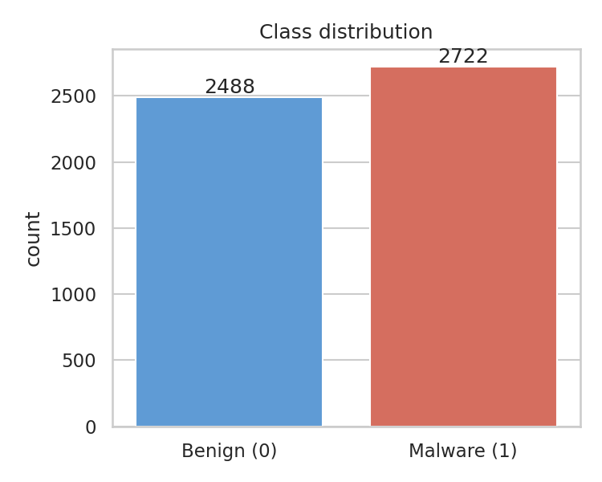
Figure 1: Class distribution of benign and malware samples.
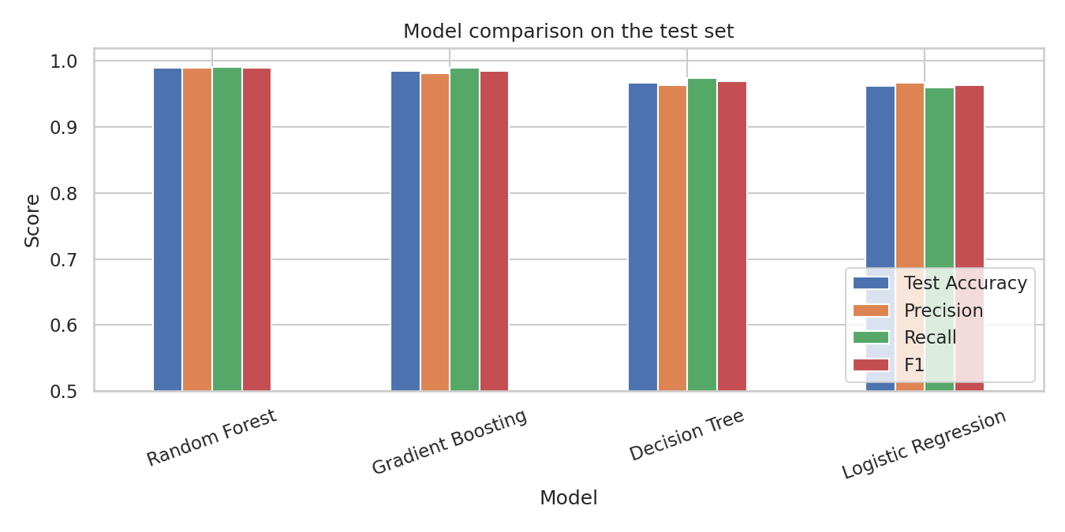
Figure 2: Comparison of the four models on the test set.
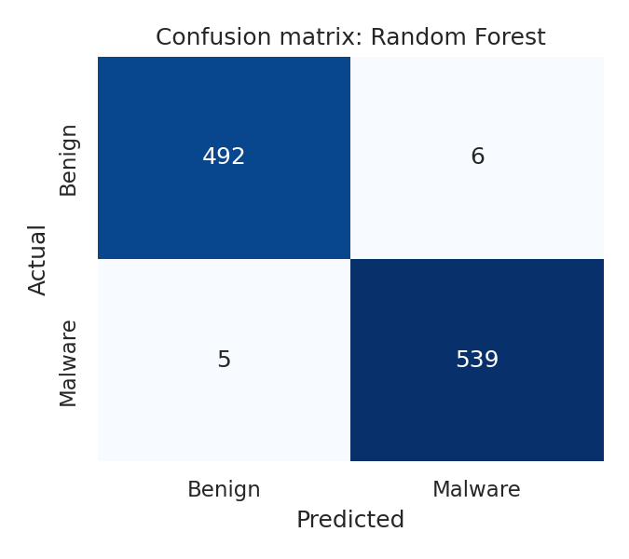
Figure 3: Confusion matrix of the Random Forest model on the test set.
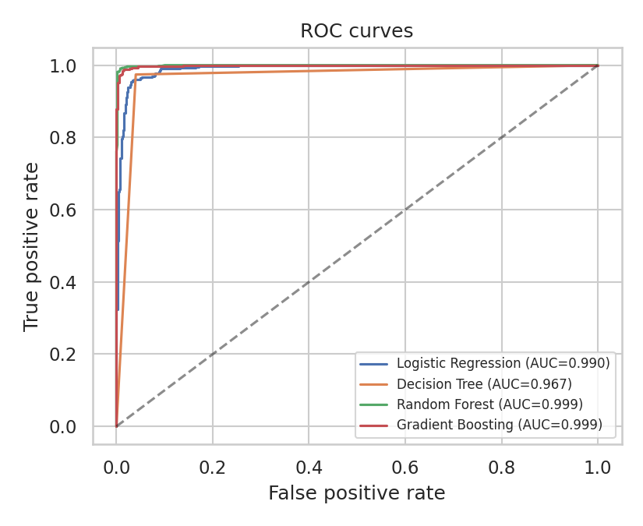
Figure 4: ROC curves of the four models on the test set.
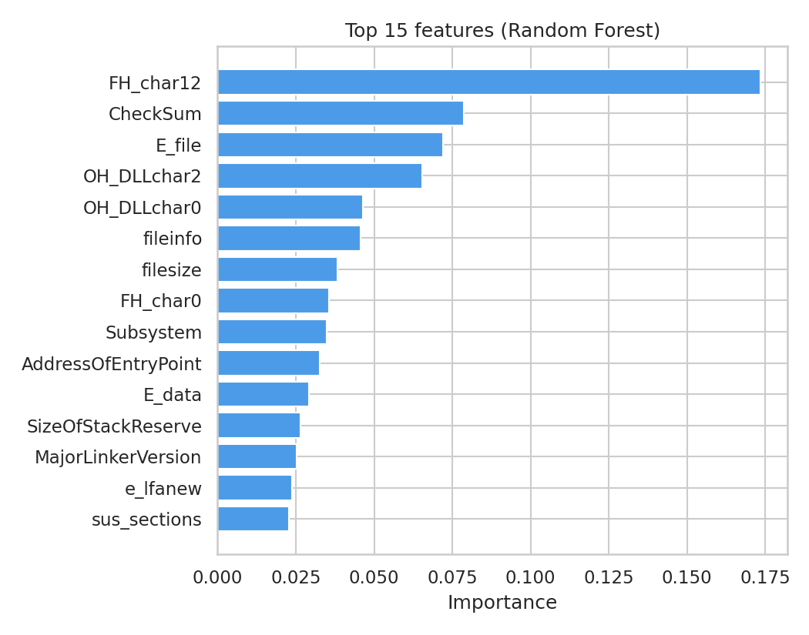
Figure 5: Top 15 features ranked by Random Forest importance.

8.2 Discussion
Random Forest was the best model, followed closely by Gradient Boosting. Both ensemble methods scored above 0.98 on accuracy, precision, recall and F1, and above 0.998 on ROC-AUC. Their cross-validation accuracy (0.9902 and 0.9866) was very close to their test accuracy (0.9894 and 0.9846), which shows that the results are stable and the models are not simply overfitting one particular split.
The single Decision Tree reached 0.9674 test accuracy. It was clearly weaker than the ensembles, which is expected, because a single tree is sensitive to small changes in the data while a forest averages many trees. Logistic Regression, the linear baseline, reached 0.9616 accuracy but a high ROC-AUC of 0.9904, meaning it ranks malware above benign files well even though its default decision threshold is slightly less accurate.
The Random Forest recall of 0.9908 means that about 99 out of every 100 malware samples in the test set were detected. In a security setting, recall on the malware class is the most important metric, because each missed sample is a threat that gets through. The ROC curves in Figure 4 show that Random Forest and Gradient Boosting stay close to the top-left corner, meaning they catch almost all malware with very few false alarms. The confusion matrix in Figure 3 shows the exact numbers for the 1,042 test files: 492 benign files and 539 malware files were classified correctly, 6 benign files were wrongly flagged as malware (false positives) and 5 malware files were missed (false negatives).
Most important features: The Random Forest importance ranking (Figure 5) is led by FH_char12, a flag bit in the file header Characteristics field, with an importance of about 0.17, more than double any other feature. It is followed by CheckSum (the checksum stored in the optional header, about 0.08), E_file (a DOS header feature, about 0.07) and OH_DLLchar2 and OH_DLLchar0 (flag bits of the DLL Characteristics field in the optional header, about 0.065 and 0.046). Other features in the top 15 include fileinfo, filesize, Subsystem, AddressOfEntryPoint, SizeOfStackReserve, MajorLinkerVersion and sus_sections. Most of the strongest signals are therefore header flags and values that depend on how a file was built and packaged, which is where malware tends to differ from legitimate software. These importances show which features the model relies on; they do not by themselves prove why a feature separates the classes.

9. Conclusion
This project showed that static PE header features are enough to build an accurate malware classifier without executing any file. Comparing several algorithms made it possible to choose the best performer using objective metrics, and the feature importance analysis showed which header fields carry the strongest signal. The saved model can be reused to score new samples.

10. Limitations and Future Work
- The dataset is relatively small and may not represent the newest malware families.
- Header values can be modified by attackers, so evasion is possible.
- Static analysis cannot observe runtime behaviour.
- Future work: add API-call and DLL-import features, use larger and newer datasets, tune hyperparameters, try deep learning, and build a simple web interface for uploading files.

11. References
- Kumar, A. (2020). ClaMP (Classification of Malware with PE headers). Mendeley Data, V1. DOI: 10.17632/xvyv59vwvz.1.
- Microsoft. PE Format specification. Microsoft Learn documentation.
- Pedregosa et al. (2011). Scikit-learn: Machine Learning in Python. Journal of Machine Learning Research, 12, 2825-2830.

